Q1:

1_first I download the VHD and attach it with 010 editors to view it.

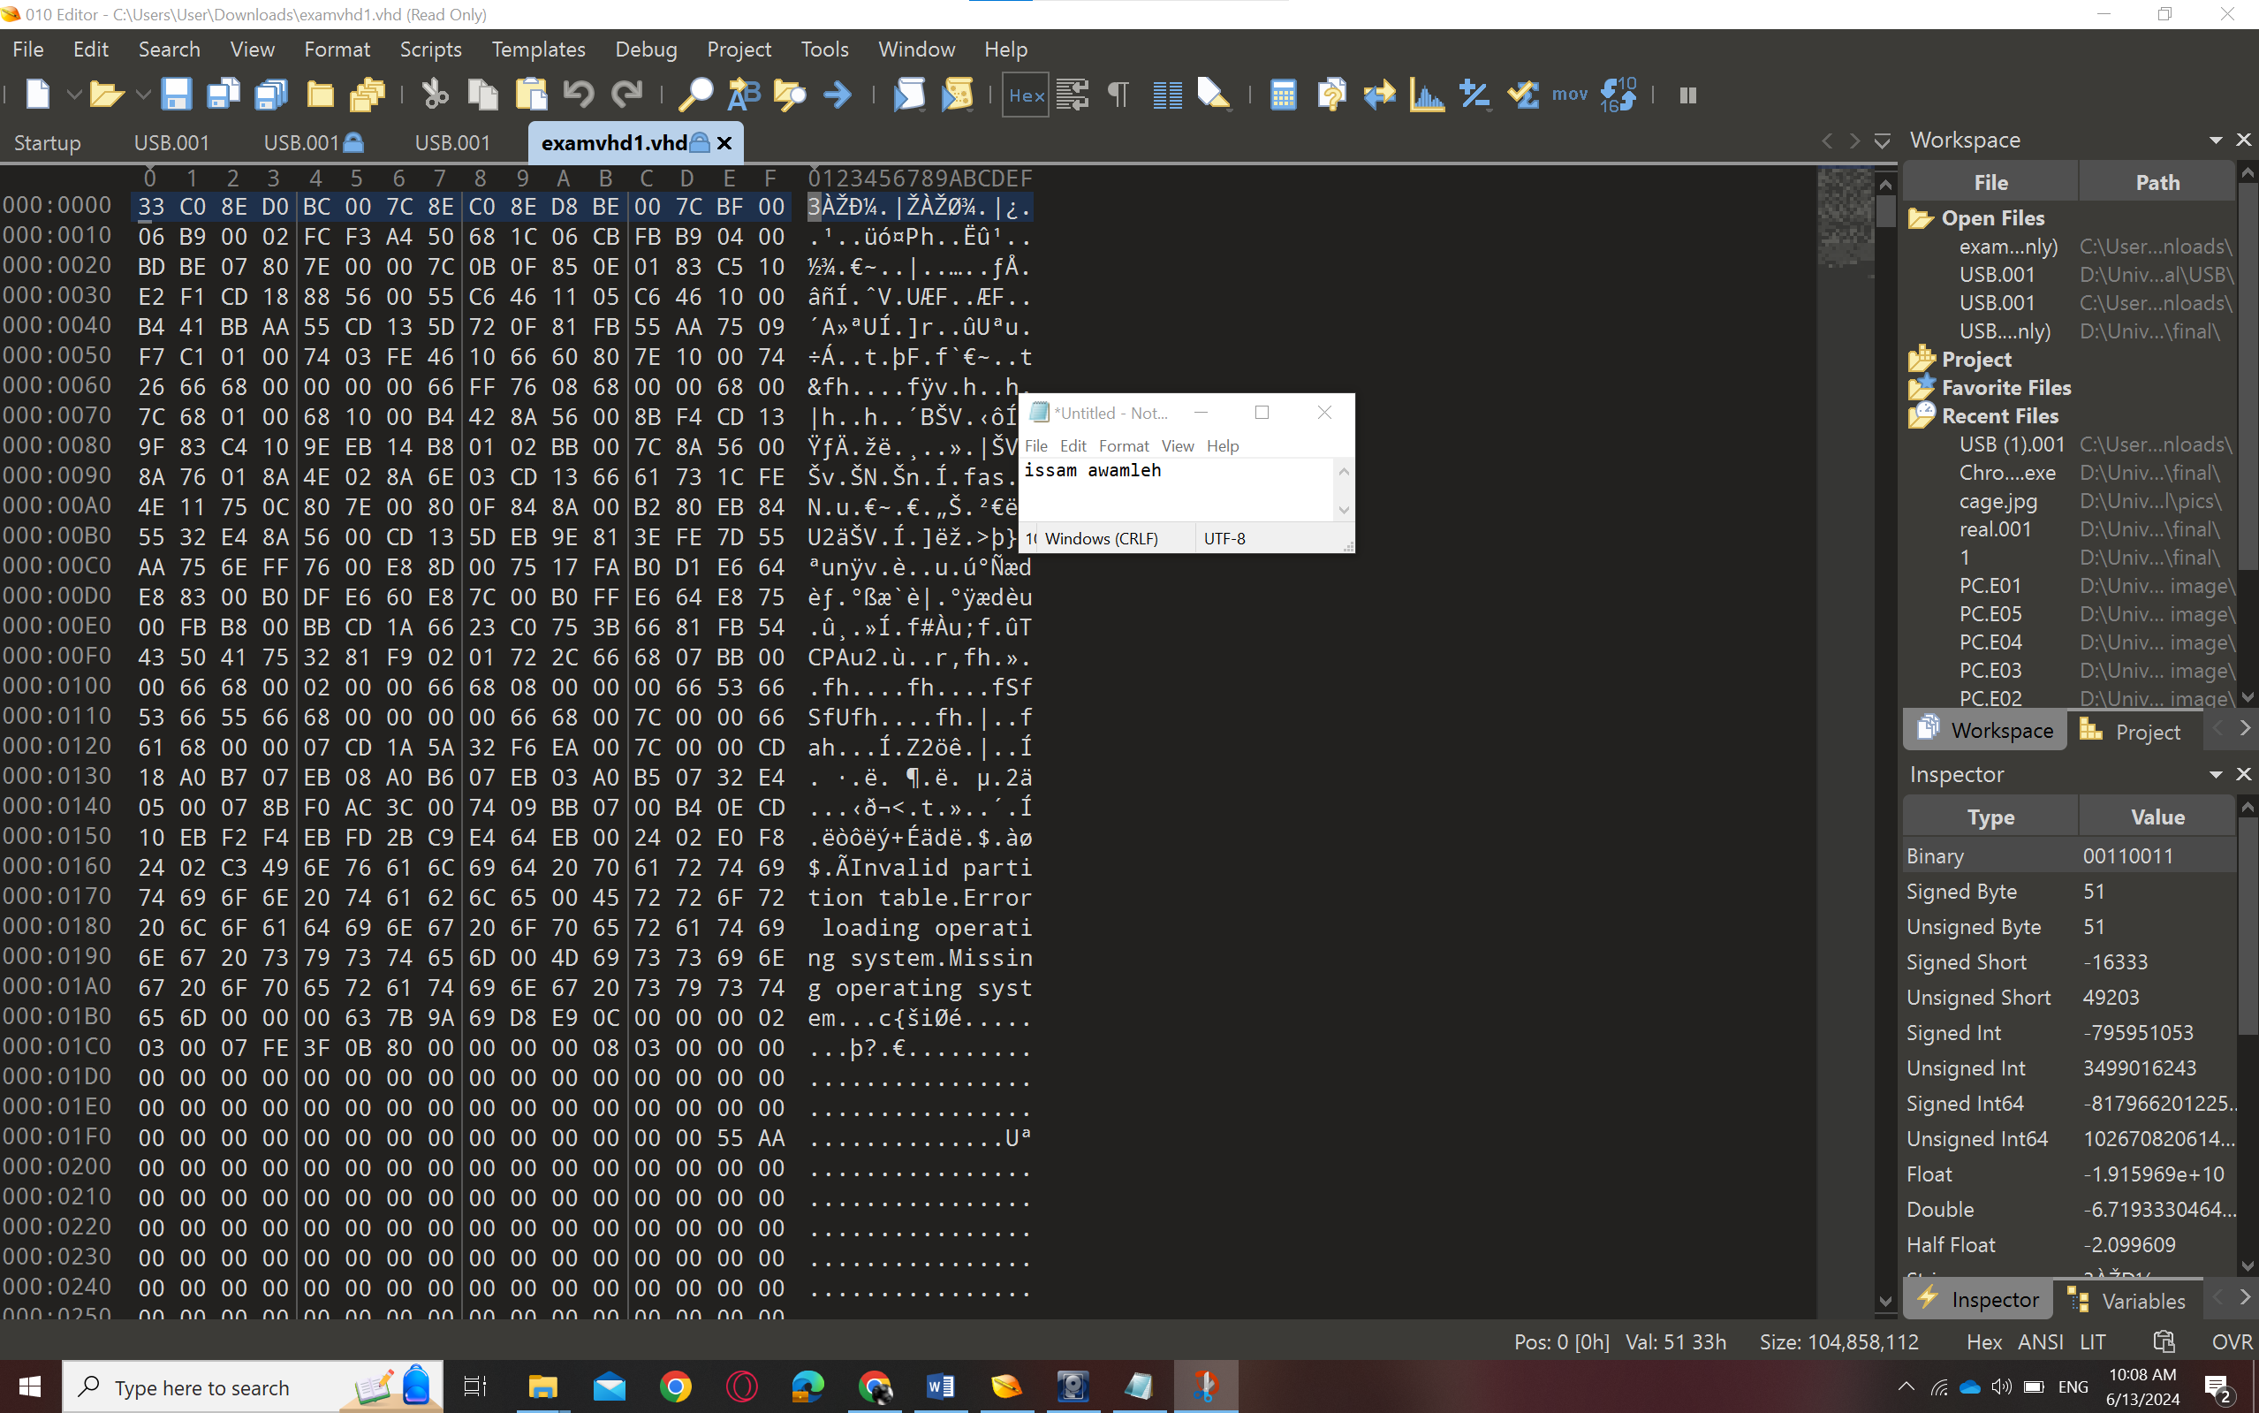

2_I look for the LBA in the MBR structure that I got:

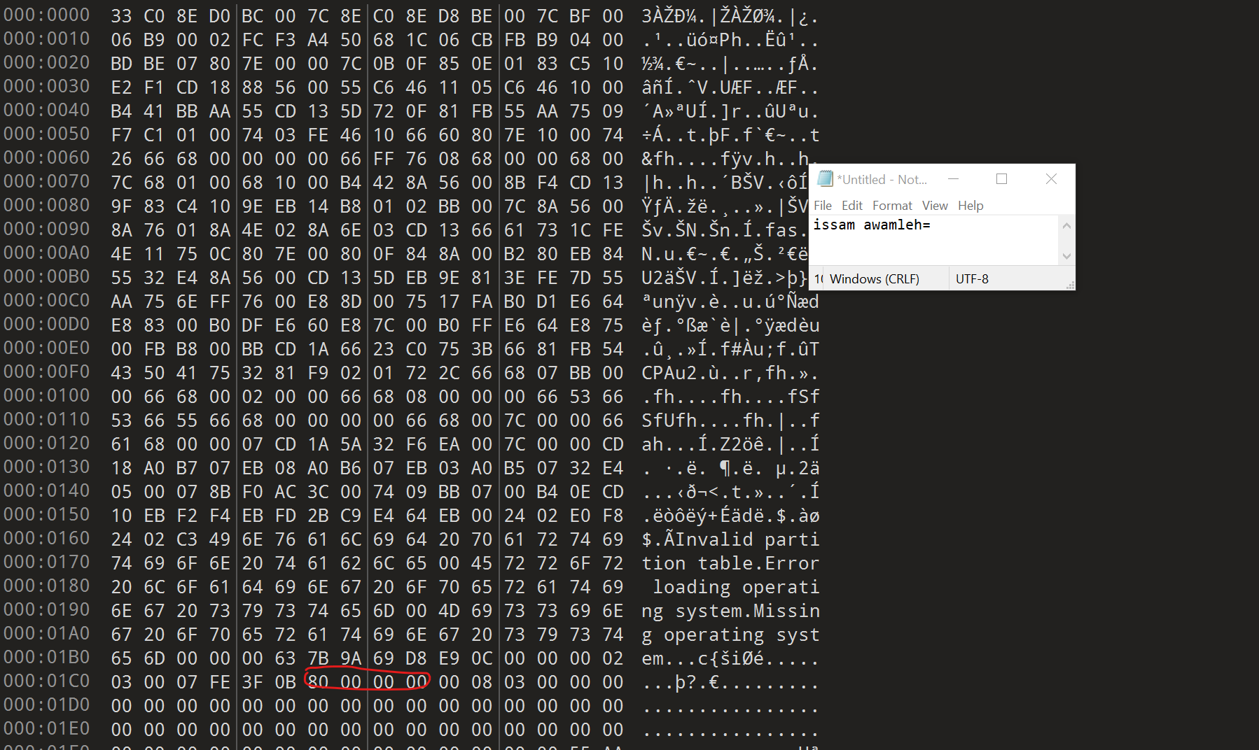

3_ the LBA is (80 00 00 00) in little endian so I convert it to big endian (00 00 00 80)

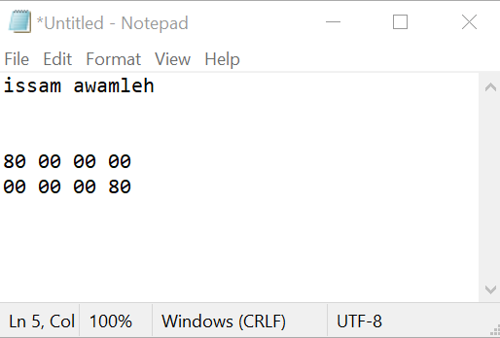

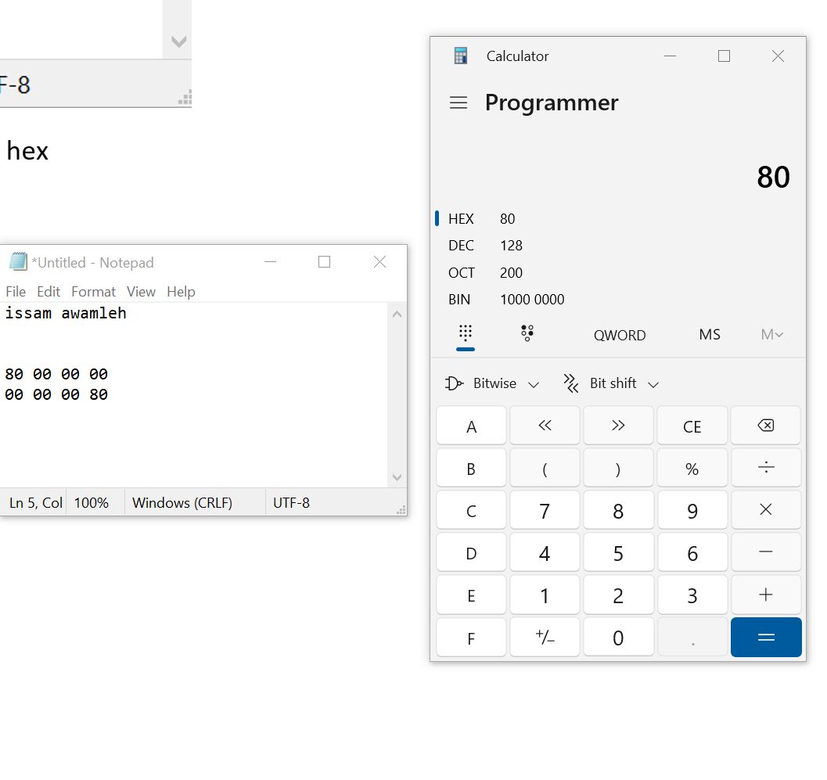

4_ so moving to the offset by 80 sector in hex:

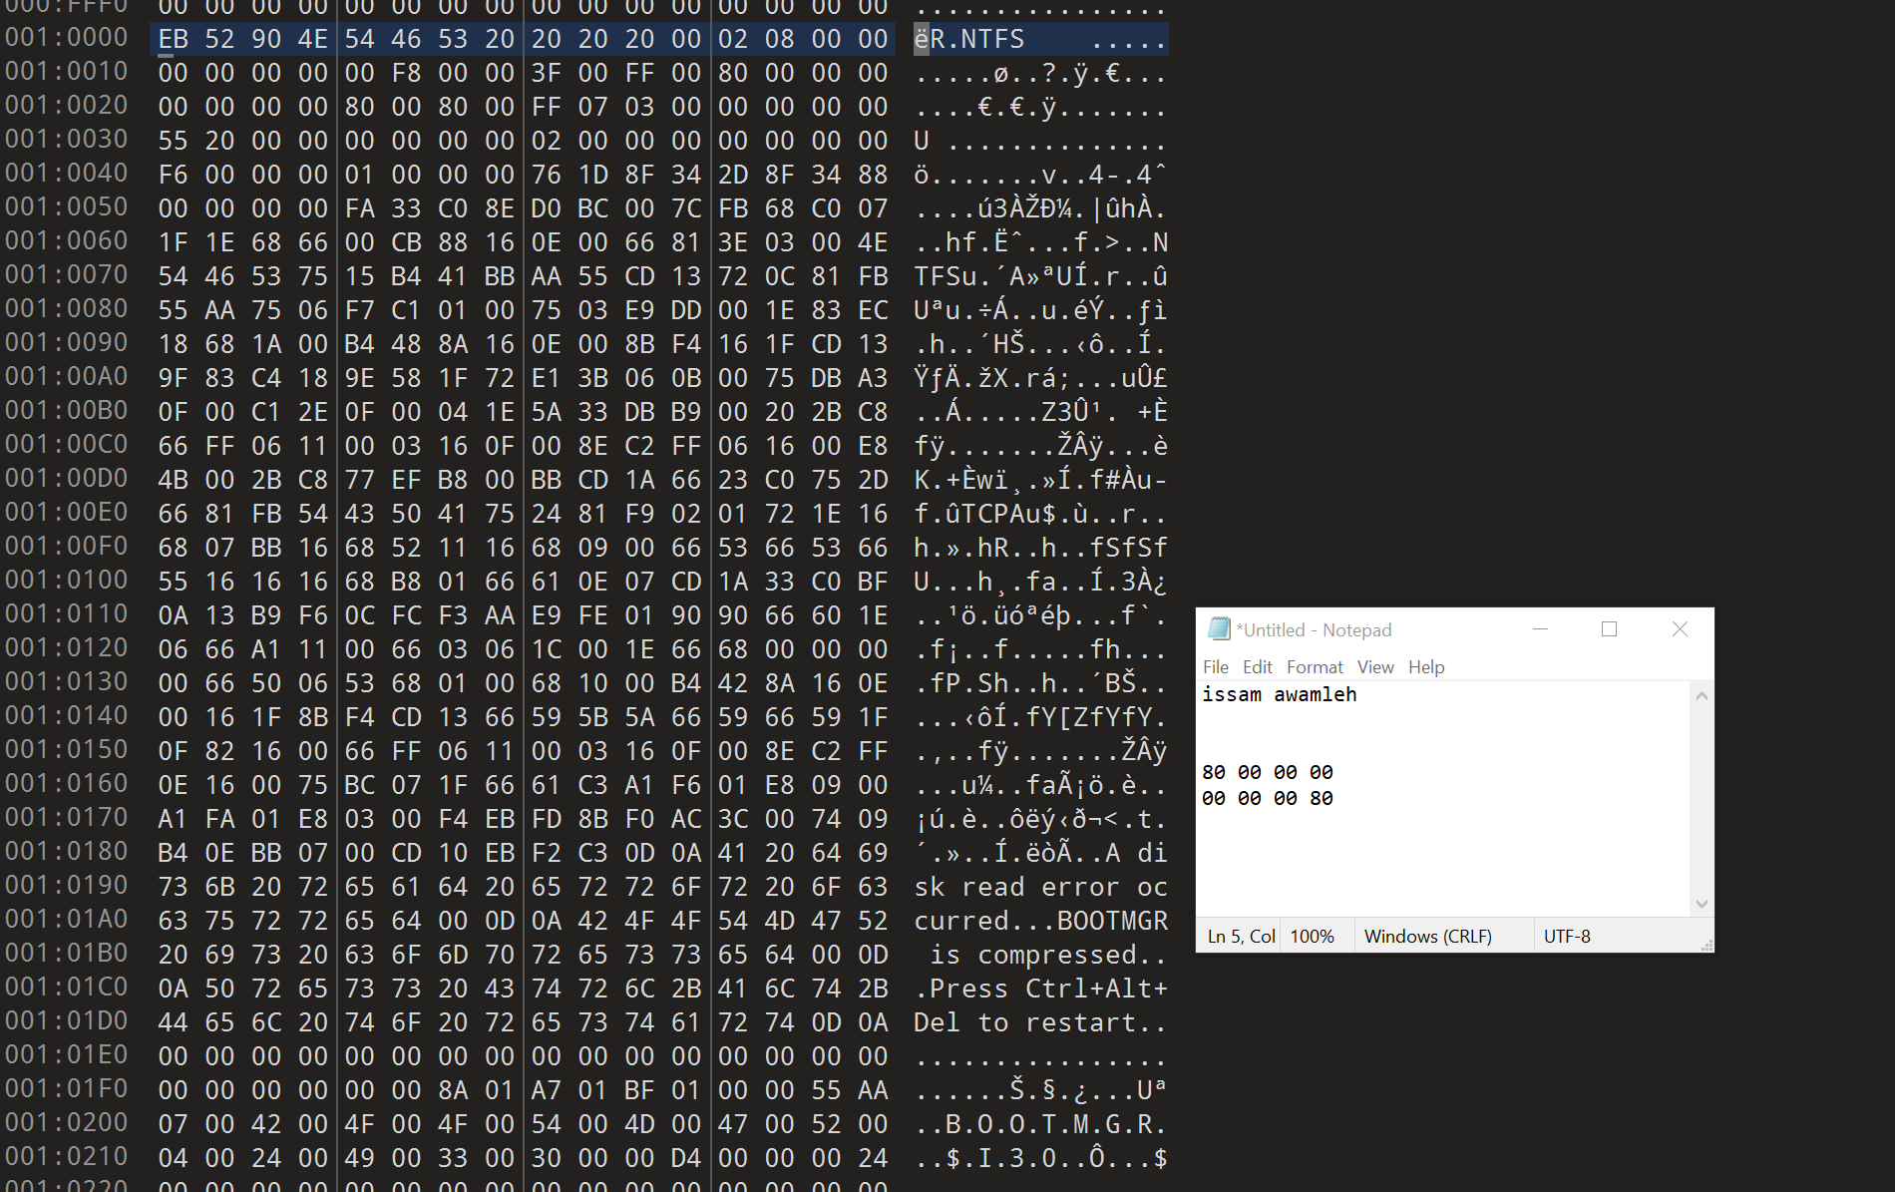

THE ANSWER IS : 80